Create a React Application named “ticketbookingapp” where the guest user can browse the page where the flight details are displayed whereas the logged in user only can book tickets.

The Login and Logout buttons should accordingly display different pages. Once the user is logged in the User page should be displayed. When the user clicks on Logout, the Guest page should be displayed.

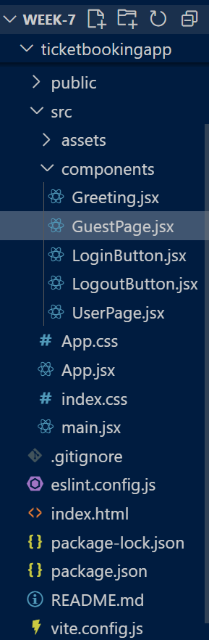

**App.jsx:**

import { useState } from 'react'

import LoginButton from './components/LoginButton';

import LogoutButton from './components/LogoutButton';

import Greeting from './components/Greeting';

function App() {

  const [isLoggedIn, setIsLoggedIn] = useState(false);

  const handleLoginClick = () => setIsLoggedIn(true);

  const handleLogoutClick = () => setIsLoggedIn(false);

  return (

    <div style={{ textAlign: 'center', marginTop: '50px' }}>

      <Greeting isLoggedIn={isLoggedIn} />

      {isLoggedIn ? (

        <LogoutButton onClick={handleLogoutClick} />

      ) : (

        <LoginButton onClick={handleLoginClick} />

      )}

    </div>

  );

}

export default App;

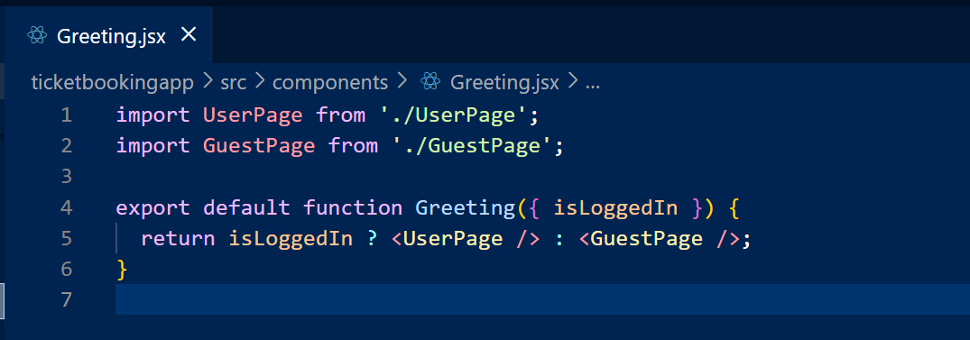

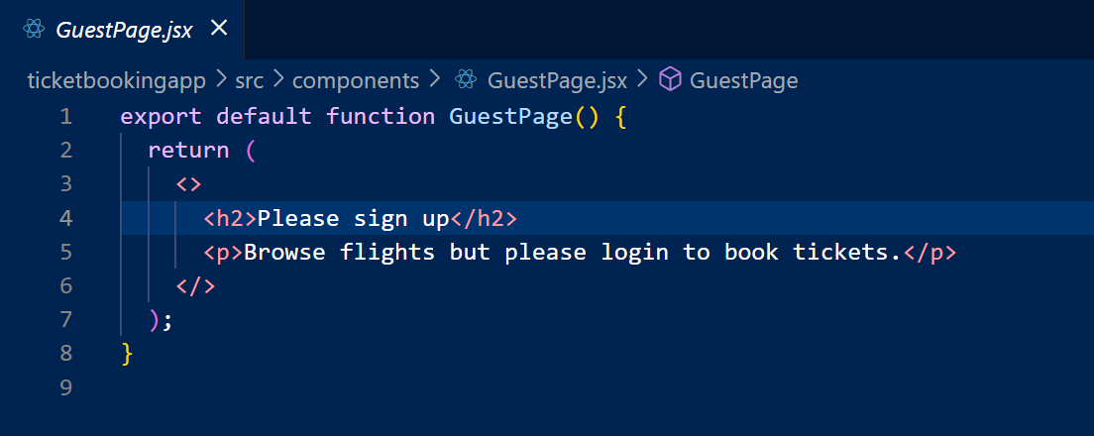  
  
  
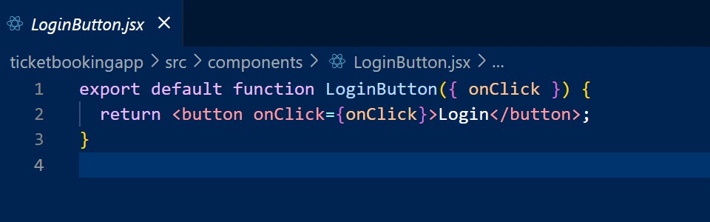  
  
  
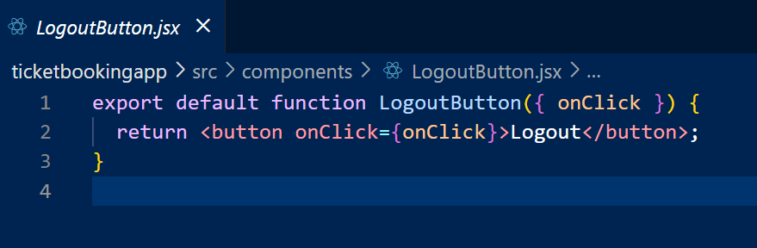  
  
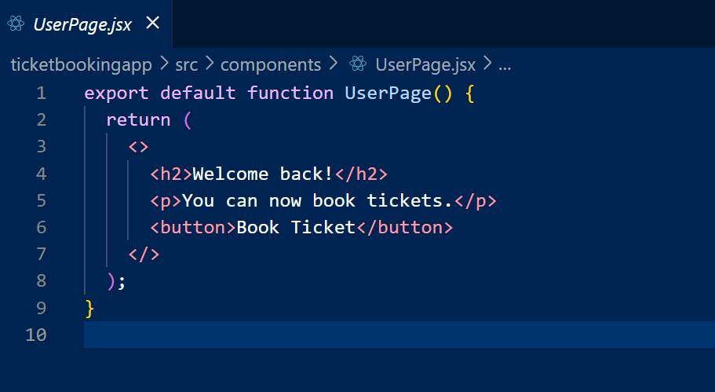  
  
  
  
  
**Output:**

**